**Best Team Prediction Algorithm (justifying why im doing it this way)**

Why not to base it solely on real life ability, the points system/rules, my approach

**Why look at the stats?**

One of the biggest mistakes that new or existing FPL players make is going for “big name” players. When they are given the choice of players they will go for all the players that are heavily talked about in the media or in their social circles. Although this is not the way to look at fantasy football. Fantasy football is a stats game not a popularity game. Even though pundits will go on about how good some players are it doesn’t always transfer over to FPL. Two examples of great players not transferring well into FPL are N'Golo Kanté and Virgil van Dijk, with Kante winning the player of the year in 16/17 and Van Dik winning the same honor in 18/19. Both players had excellent seasons, coming in for big money moves, and were instrumental to their teams doing well that season with Kante helping Chelsea win the league and Van Dijk steadying a leaky Liverpool defense.

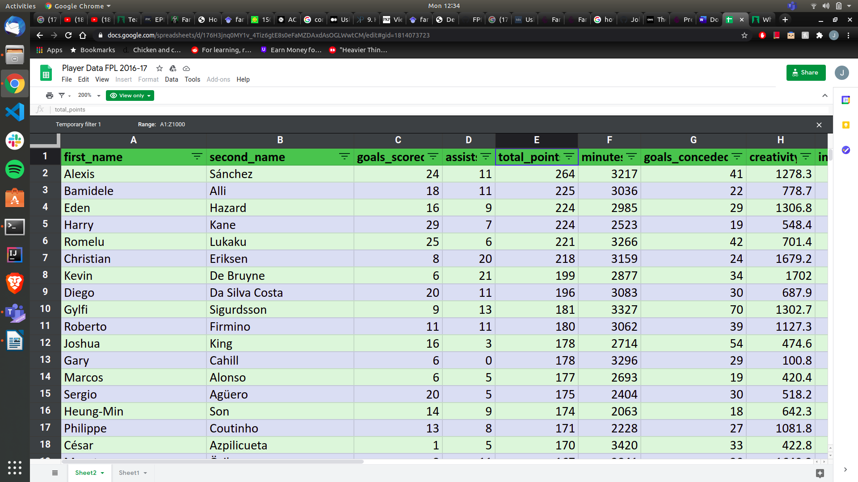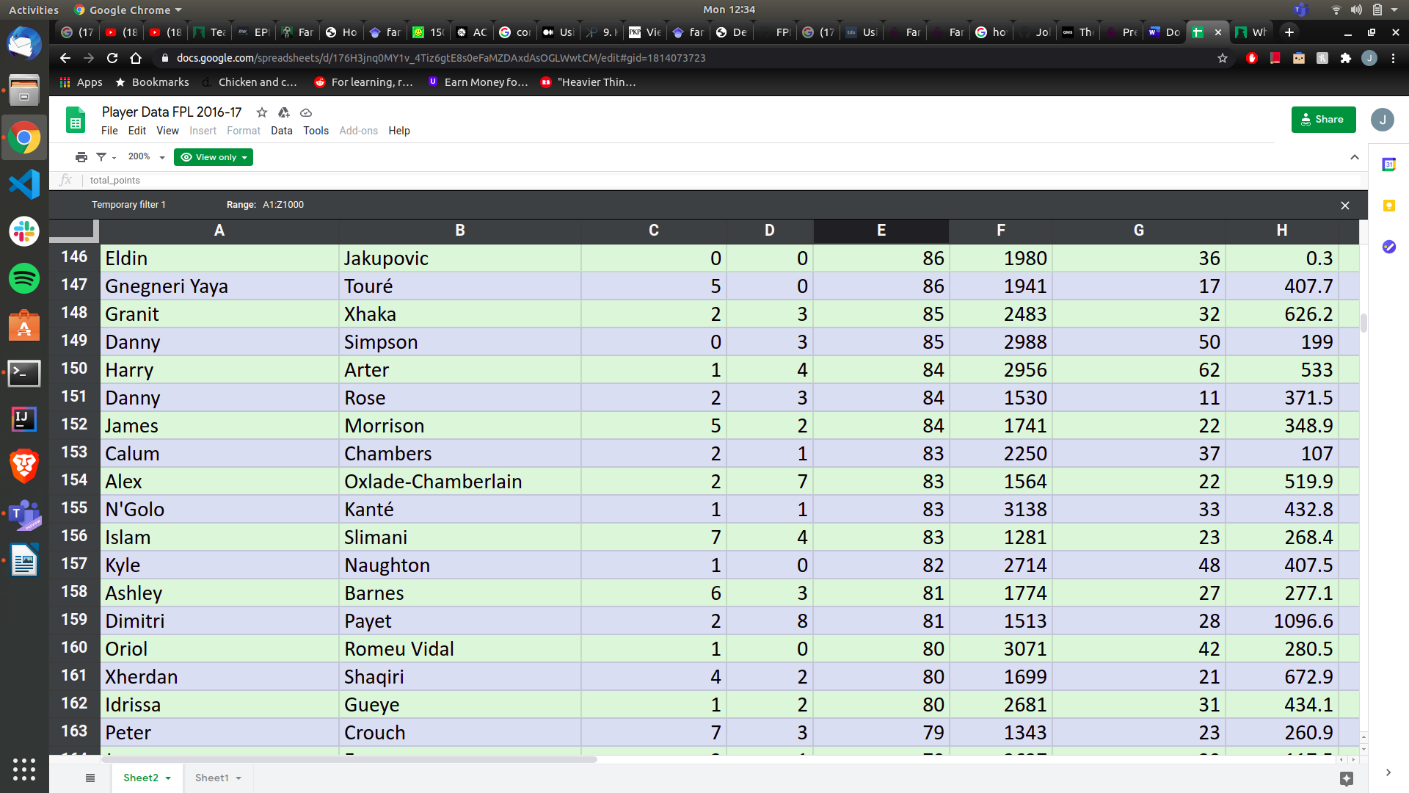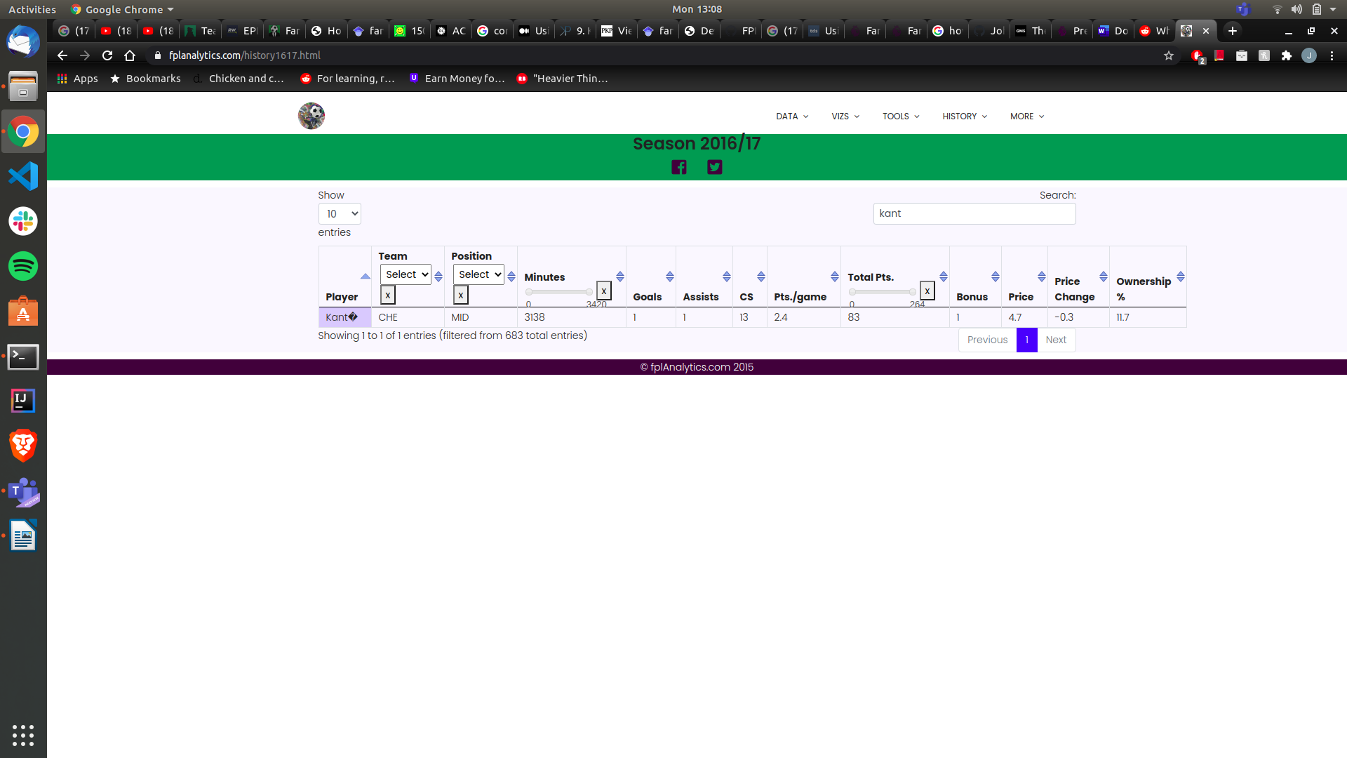Figure 1: 16/17 FPL player season stats [#]

But as these figures show real life ability doesn’t always move over to FPL. The season that Kante won the player of the year award he only came in 156th place for points. A drastic 181 points off the top most points. The main reason for not being a goof FPL option is due to his role as a player which is a defensive midfielder. (if point system is mentioned before or after this) a midfielder only gets one point for clean sheets so with this system Kante doesn’t get as many points as the defenders who get 4. So, because Kante doesn’t offer much in the attacking sense of goals and assists and only gets one point for his defensive contribution he is not a good FPL option

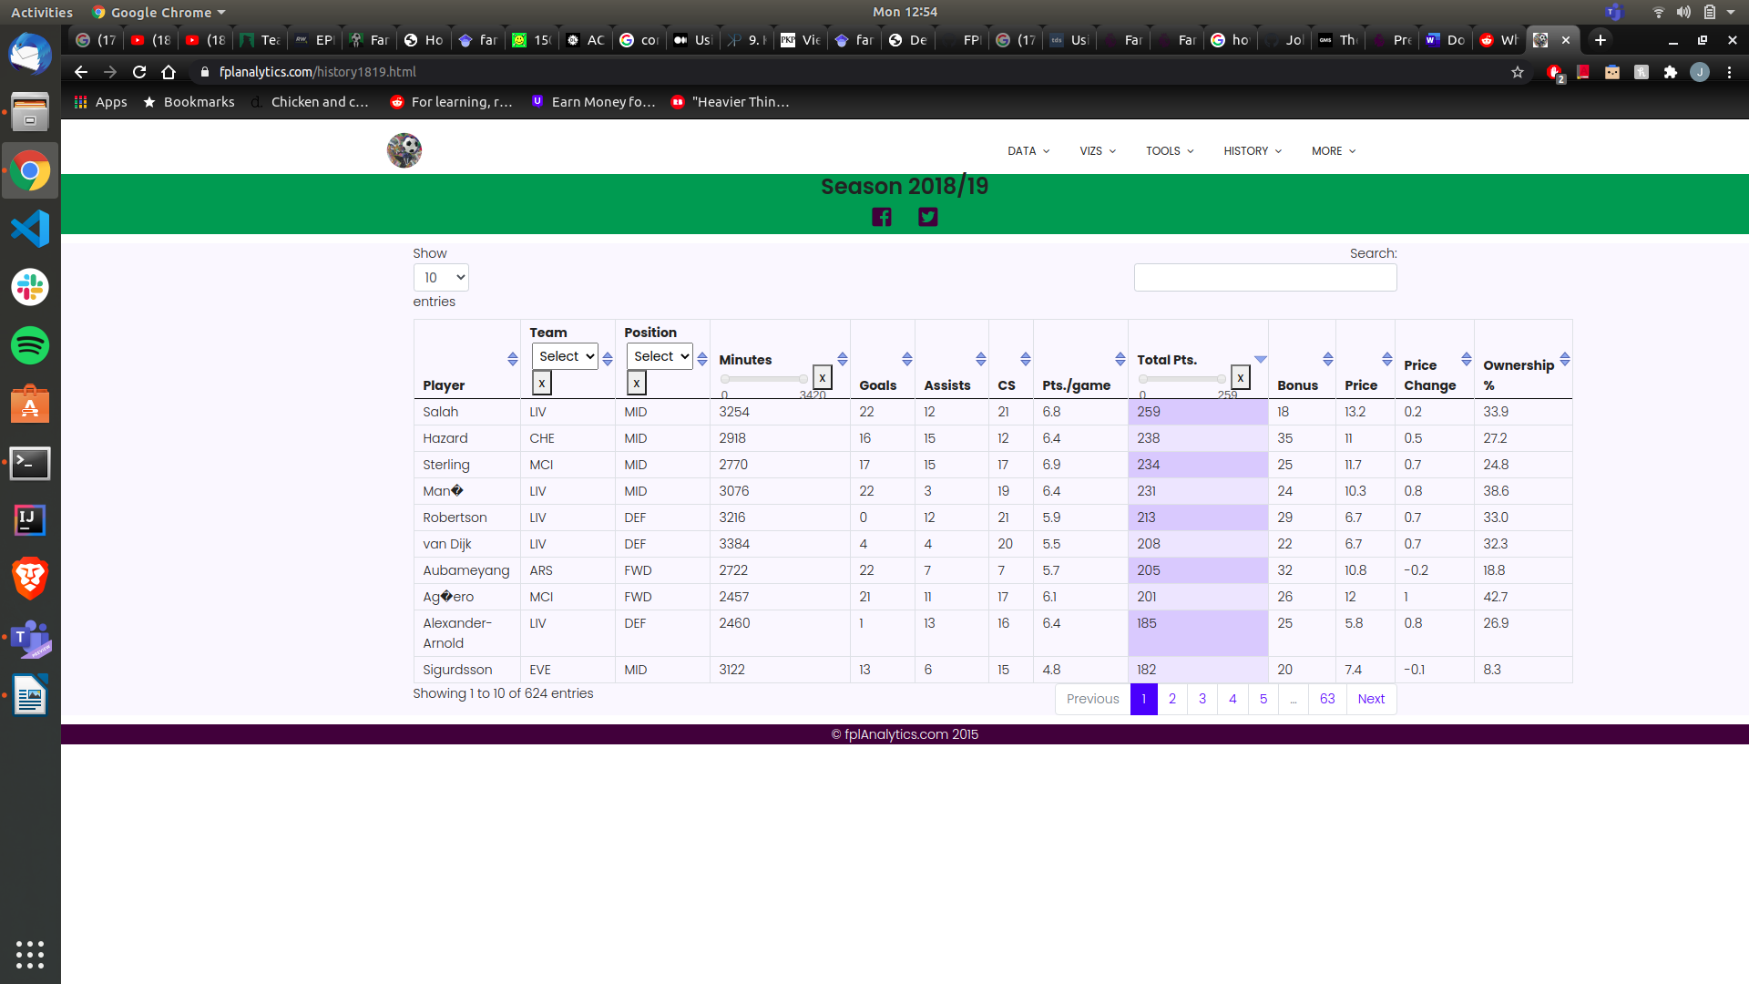Figure 2: 18/19 FPL player seasons stats [#]

Van Dijk suffers a different problem than Kante does. Van Dijk is a highly renounced player and greatly improved Liverpool's defense which resulted in them winning more games [#]. When he is playing Liverpool have a 70.5% win rate and concede an average of 0.94 goals per match. When he isn’t playing however Liverpool have a drastic 42.9% win rate and concede an average of 1.57 goals per match. So without Van Dijk playing Liverpool concede more goals and lose more games. Conceding less goals mean more clean sheet points and if they’re winning more games they have to be scoring more goals. So Van Dijk is fundamental to Liverpool playing well, keeping clean sheets and is highly praised, winning player of the year that season. Even with all of that Van Dijk was still not the highest scoring defender, or even the highest scoring Liverpool defender for that matter. Andy Robertson (Liverpool left-back) has outscored Van Dijk every season for Liverpool as seen below.

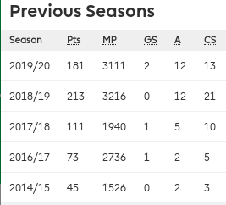 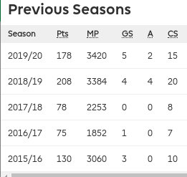

Figure 3 : Robertson vs Van Dijk season stats [FPL website, in transfers]

The main reason for this is because Robertson is a full-back and Van DIjk is a center-back. Center-backs are a traditionally more defensive and full-backs have the ability to be more attacking. Since they have this freedom to go further up the pitch they are more likely to get assists more often. Where center-backs are more likely to get goals from corners (due to their height) but far less often. So in summary a Player shouldn’e be picked solely on their on pitch ability but instead how likely they are to do things that result in point and not losing points.

**Rules and Scoring System**

FPL like any other game has a set of rules that all player have to follow [#}. The following are the ones that involve picking your team as these are the only ones that apply to my prediction algorithm.

Game Rules

* Users have a budget of 100 million to spend on players
* A squad must have 2 Goalkeepers, 5 Defenders, 5 Midfielders and 3 Strikers
* Each week you must pick 11 players to play (1 GK, 3-5 DEF, 2-5 MID, 1-3 FRW) and 4 on the bench
* Can only have 0-3 player from one team in the squad

Literature Review:

Medium.com: goes over linear programing. Says to use regression

<https://medium.com/ml-everything/using-python-and-linear-programming-to-optimize-fantasy-football-picks-dc9d1229db81>

Same idea, maybe more tutorial kind of article:

<http://www.philipkalinda.com/ds9.html>

Not a fan but read again:

<https://arxiv.org/pdf/1505.06918.pdf>

Gold:

<https://ntnuopen.ntnu.no/ntnu-xmlui/bitstream/handle/11250/2577003/19403_FULLTEXT.pdf?sequence=1&isAllowed=y>

Still to read:

<https://ojs.aaai.org/index.php/ICWSM/article/view/3213/3081>